Quality Management
For Mouse Gesture Pattern Recognition Development
By Artificial Neural Network

– Final Report

By

Gang Hu(ID 5258235)

Date: April, 2007

Abstract

This project is to combine the knowledge and methods of quality based system engineering we learnt from quality based system engineering course and the ANN knowledge to program, design and develop an ANN of Mouse Gesture recognition application with an integrated measurement/test tool that can help us to tweak and tune the ANN performance. Quality measurement is a key for this project, and many testaments are done for better tuning and tweaking the ANN model. The quality improvement is divided into two ways, performance and features.

- Introduction

This project is to combine the knowledge and methods of quality based system engineering we learnt from quality based system engineering course and the ANN knowledge and programming to design and develop an ANN of Mouse Gesture recognition application in which we tried to make almost every design/development step under the guide of those knowledge. This project developed an ANN program &application which can identify a user's mouse movement on a small user interface window which locates at the corner of windows screen. It can judge what the mouse movement sequence and what the make up pattern is, such as from left to right, right to left, up to down or down to up, and some specific movements like clockwise triangle, counterclockwise square, etc. Then if a pattern is recognized as one of the stored known patterns, it can do some specific things predefined by users, such as opening an application, or activating an antivirus program, etc.

The mission and vision statement was built first to explain what our project software development purpose and general idea, and we then identified Customers and discover their Needs.

For making this project measurement convenient, we created a separated test program. It generalizes a standard shape first (triangle and square), then rotates it to a fixed angle, records the guessing possibility value, and then increases a specific step on the angle to do the test again. It can rotate from -45 degree to 45 degree, under 30 steps. We record the result and draw statistical chart as references, corresponding to each test group. This is a good reference for us to tweak and tune the ANN parameter to improve its performance and especially the generalized capability.

Base on that measurement, we improved our project program performances which used those measurement data as references. Here the improvement was divided into two parts, one is the function and feature improvement and the other one is program performance /ANN performance improvement.

Finally, this project followed these quality system engineering steps strictly; it created a good project program and test result, including a successful demo program.

2 Quality Planning

2.1 Establish the Project

With the complexity and cost of system engineering in industry increasing screamingly fast during the recent decades, quality based system engineering is becoming more and more important to guide researcher/developer from the top to bottom of the design and manufacturing. The artificial neural network (ANN) is also a hot topic and an important AI technique in engineering. It has been applied successfully in many fields, such as industry control, computer, game, and quality control area. This project combined the knowledge and methods of quality based system engineering we learnt from this course and the ANN knowledge and programming to design and develop an ANN of Mouse Gesture recognition application in which we try to make almost every design/development step under the guide of those knowledge.

2.2 Mission and Vision Statement
Developing and applying ANN into this project include: selecting and designing the program input/output/controls; constructing and establishing the neural network architecture; encoding networks; algorithm; training; and the whole procedure programming, debugging, testing which under the guide and apply the system engineering knowledge.

This project is to develop an ANN program &application which can identify a user's mouse movement on a small user interface window which locates at the corner of windows screen. It can judge what the mouse movement sequence and what the make up pattern is, such as from left to right, right to left, up to down or down to up, and some specific movement like clockwise triangle, counterclockwise square, etc. Then if a pattern is recognized as one of the stored known patterns, it can do some specific things predefined by user, such as open an application, or activate an antivirus program, etc.

Furthermore, we made it more attractive for customer to add learning function to satisfy user's further need, such as it can learn a user customize mouse movement sequence, and then open user customized application, or acting as a password/signature verification interface, etc.

For the vision statement of our project, we are trying to make a unique, creative, user friendly and leading product in the market; also we could provide core code with free download for those who are interest in how it works and want to learn ANN application programming.

2.3 Establish a Team to do the Planning
Based on each team member’s background and project requirement, we set-up our team which has Quality control and assurance, quality engineer, product engineer (software developer), marketing customer services (support engineer) and team manager.

Project Manager: Gang Hu
Product Engineer (software developer): Gang Hu & BeiChen Li
Quality Engineer: BeiChen Li and Yi Huang
Support Engineer: Malik Qasaimeh
More detail please refer to section 2.1

2.4 Plan the Execution of the Project
1st week: developing the objective which include project and mission statement,

2nd week: team planning

3rd -- 4th week: identifying customers and collecting customer requirements

5thweek- 10th week: product design and software development

11th week: product test and quality assurance

12th week: quality improvement and verification

2.5 Identify Customers and Discover their Needs

We aim at four categories of customers as follow:
1) Novices and beginners who are not familiar with the computers and operating systems and who want to have simple tools to access their intended programs. We provide them with our product which is easy to use, intuitive and interactive and has simple patterns to use.
2) Windows platform hobby users (advanced users) who want to shorten the operation time to access their programs/ applications efficiently.
3) The users who need to access their programs and application based on authentication process by using the product which is designed to recognize their gestures and signatures.
4) Developers and programmers who are interested in the artificial neural network programming. Our product delivers with free codes and detailed documentation as well as free-use license.

2.6 Customer requirements
After defining the customers, we analyzed their needs and identified the customer requirements as follow:
1) Quick response
2) Simplicity
3) Flexible
4) Accuracy
5) Expandability (learning ability)
6) Usability
7) Maintainability
8) Reliability
9) Functionality
10) Price
11) Availability
12) Modularity
13) Error-tolerance
14) Reusability
15) Interoperability

2.7 Develop the Product
Design requirements come from environment. The environment can be divided into Natural environment, built environment, and human environment.
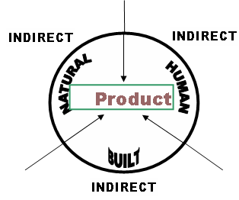

Based on the analysis of the conflicts between the environments, we identified customer requirements and technical specifications. Technical requirements are design characteristics that describe the customer requirements as expressed in the language of the designer or engineer. This product has following seven features:

1) Mouse gesture recognition
2) Mouse drawing sequence pattern classification (or signature)
3) User friendly interface
4) Easy to use
5) Suitable for the people from beginner to advanced users
6) Great learning ability and expandability
7) Help users to open specific or customized application/programs just by mouse movements

Relationships between the customer requirements and technical requirements:
The house of quality is used to relate the customer requirement to the product features. The relationships between these requirements and features provide with an important way to understand customer needs and give up the strategic direction for the product design.

 |  |  |  |  |  |  |  | ●
 |  |  |  |  |  |  | Δ
 |  |  |  |  |  | ○ |  |  |  | Δ
 |  |  |  |  | ○ |  | ○  Δ |  | ● |  | ●
 |  |  | ● |  | ● |  | Δ |  |  |  | ○ |  | ○
● Very strong relationship  ○ Strong relationship  Δ Weak relationship | Mouse gesture recognition |  | Mouse drawing sequence pattern classification (or signature) |  | User friendly interface |  | Easy to use |  | Suitable for the people from beginners to advanced users |  | Great learning ability and expandability |  | Help users to open specific or customized applications/programs just by mouse movements
Quick response | ● |  | ● |  |  |  |  |  | Δ |  | ○ |  | ○
Simplicity |  |  | Δ |  |  |  | ● |  | ● |  | ○ |  | ○
Flexible |  |  |  |  |  |  |  |  | Δ |  | ○ |  | ●
Accuracy | ● |  | ● |  |  |  |  |  |  |  |  |  | ●
Expandability (learning ability) |  |  |  |  | Δ |  | ○ |  |  |  | ●
Usability | ● |  | ● |  |  |  | ○ |  |  |  | ○ |  | ●
Maintainability | ○ |  | ○ |  |  |  | ○ |  | Δ |  |  |  | ●
Reliability | ● |  | ● |  |  |  |  |  |  |  |  |  | ●
Functionality | ● |  | ○ |  | Δ |  | ○ |  | ○ |  | ● |  | ○
Price
Availability | ● |  | ○ |  |  |  |  |  | Δ |  |  |  | ○
Modularity | ● |  |  |  |  |  | ●
Error-tolerance | ● |  | ● |  |  |  |  |  | Δ |  | Δ |  | ○
Reusability | ● |  | ○ |  |  |  | ● |  | Δ |  |  |  | ○
Interoperability | ● |  | ● |  | Δ |  |  |  |  |  |  |  | ○

For the mouse-based interaction, we decided to simplify the definition, while still keeping the notion usable: a mouse gesture is a continuous, directed sequence of the mouse cursor movements with the clearly distinguished start and end, e.g. by using of the predefined combination of mouse or keyboard keys. In our work, gestures are marked by pressing the left button.

Our goal is to recognize and classify a directed sequence of the cursor movements done with the left button pressed as belonging to one of the established classes.

2.8 Develop the Process

ROM Linguistic model analysis:

Quality Management

for

Development
Recognition
Mouse Gesture Pattern

by

Artificial Neural Network

The product design focuses on the development of system and the deployment of system. System thinking activities are involved to ensure all the requirements are met. To produce the product features, we have six steps for the product development figure 5.
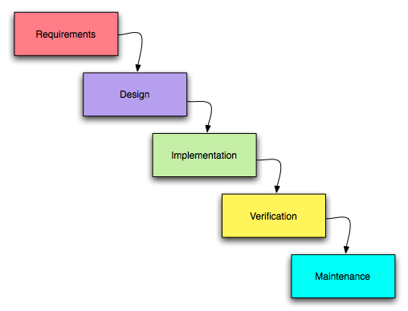
Figure 5: ANN model and work flow in this project

Why do you need a product development process? Quite simply it controls the costs and time taken to develop a new product. More importantly it helps to look on product development as investment rather than risk.

The process approach is a management strategy. When managers use a process approach, it means that they manage the processes that make up their organization, the interaction between these processes, and the inputs and outputs that glue these processes together.

The purpose of developing process is to ensure complete and accurate identification of the problem, selection of the best alternative, enhancement of agency credibility, and efficient use of resources in short, to ensure that good transportation investment decisions are made. A decision process incorporates the following elements.

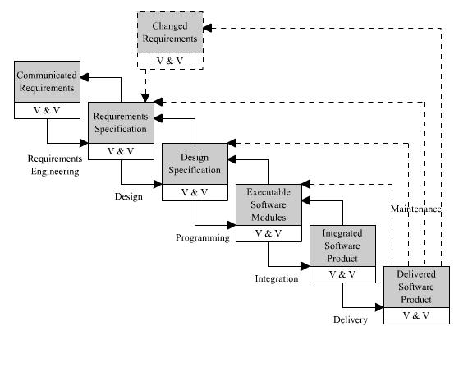

Figure 6: Design Feedback Loop
The waterfall model is a popular version of the systems development life cycle model for software engineering. Often considered the classic approach to the systems development life cycle, the waterfall model describes a development method that is linear and sequential.
- The model suggests that software engineers should work in a series of stages.
- Before completing each stage, they should perform quality assurance (verification and validation).
- The waterfall model also recognizes, to a limited extent, that you sometimes have to step back to earlier stages.

The advantage of waterfall development is that it allows for departmentalization and managerial control. A schedule can be set with deadlines for each stage of development and a product can proceed through the development process like a car in a carwash, and theoretically, be delivered on time. Development moves from concept, through design, implementation, testing, installation, troubleshooting, and ends up at operation and maintenance. Each phase of development proceeds in strict order, without any overlapping or iterative steps.

2.9 Optimize Self Control and Self Inspection

In order to meet our quality objectives and product design specifications, all the team members work in a state of self-control. Every team member has adequate training on quality management to deal with the problems to be occurring during the implementation of the project. All the members are taking the quality systems engineering relative courses. And their background on quality is useful in the project. Furthermore, the following work as the guidance for team members in the project:

Every member has a clear understanding of what he is supposed to do in the project. Every member’s work is performed based on the six steps of developed process. Clear and complete performance standards are carried out to assure the accomplishment of the project.

Team members review timely their actual performance in the process. Design feedback loop provides good instructions to the project reviews so that actual performance can be checked and compared to the specifications.

Every one, especially the software developer, must have the ability and desire to regulate the process for minimum variation. The team members make suitable adjustments to minimize variation and maintain the inherent process capability.

The project is implemented in a friendly quality oriented environment. Team members consider quality as the number 1 priority. The software developers took more responsible for the quality of their work and applied the self-inspection in the design process.
3 Product design and Implementation

3.1 ANN Background

An artificial neural network attempts to mimic some amount of parallelism within the constraints of computer, and in doing so, display a number of similar properties to a biological brain.

Some properties of a biological brain works:
1) It can learn with/without supervision;
2) It is tolerant to damage;
3) It can process information extremely efficient;
4) It can generalize;
The ANN has some features as follow:
- Generic nonlinear functional element – can implement any MIMO mapping function to arbitrary accuracy (universal approximate)
- Need to be “trained” with data
- Supervised training: applied when we already have examples data; unsupervised training: applied learning algorithms to adjust the weights.
- Parallel architecture nature, but can be implemented on serial computer
- Black box – difficult to understand inner workings
- Useful for modeling data-rich/theory-poor processes, such as pattern recognition, non-linear control, prediction, skill game AI (like car driving), and so on.

This project gave the ANN approach to recognize mouse gesture pattern input types through building and implementing an ANN model on classifying 6 basic types of pattern. The model has most of these ANN features mentioned above. It also can be expended to any types of as many types of mouse gesture pattern as customer want in real environment and no matter how many types applied, the result show that they would have similar classification rate and trend.

3.2 ANN Model Design for Mouse Gesture
Step 1: Selection of feature vector for neural network in this project

We consider the mouse movement on the screen as input, the mouse button as a switch to active the collection of mouse movement points and response to ANN recognition. So, we choose 16 points as vector, and each include X and Y axial value. Therefore, we have 32 input data.

Usable gestures can not be complicated drawings, as they must be performed on the limited area of the screen and relatively easy to be repeated with a significant similarity. We propose relatively simple gestures as possible, e.g. the examples presented on the Fig.1 Finally, we distinguished different pattern as the basis for the further experiments.
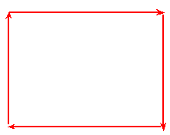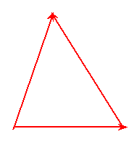
Down left up right rectangle triangle

Figure1: simple mouse gestures

The possible beginning of a gesture is signaled by pressing of the right mouse button. From that moment, until the release of the button, each change in the location of the cursor is registered and added to a vector of points. During the experiments the users intentionally performing gestures were practically drawing them at once. The order of points in vectors defines directions.

Step 2: Model of ANN structure Selection

The neural network structure for this project is shown on figure 1. This is a three layers’ feed-forward network which includes input layer, hidden layer and output layer. Each layer contains a certain number of neurons which are given in detail in the next section. The structure of this ANN model mainly based on input and output data vector structure. For the hidden layer, it needs many experiments to test how many neuron numbers can achieve the best result and minimize the neurons used.

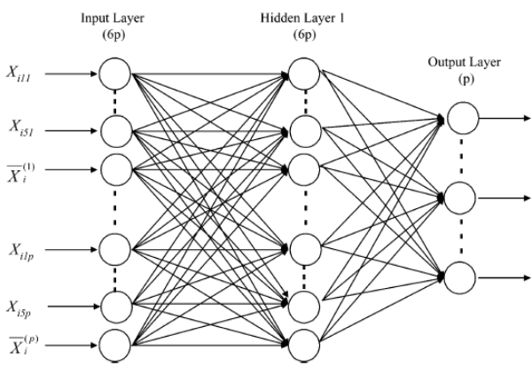
Input layer: As we mentioned above, totally we have 16 input points and each has two vectors, so the input layer should has 32 neurons.
Hidden layer: The hidden layer we need to do test to find out the best number because no strict/accurate algorithm or mathematic model to define the hidden neuron numbers so far. However, there is a rule that minimize the hidden neuron number in hidden layer can lead to less chance to cause the over-fit problem. So what we did is that firstly, choose a relative large neuron number for hidden layer, building the model, finish the training, and then start the testing. Each time, we just remove one neuron to see if any difference happen such as the ANN performance going down or classification capability is degrading. Here we started to use 16 neurons in the hidden layer, then after many tests which each time remove one to see what happen, we stopped at 6 hidden layer neurons, which can provide good generalized ability, less over-fit and the performance of classification is also well balanced. Therefore, we chose 6 (actually if it is among 8 to 12, all may relative good) neurons for the hidden layer.

Output layer: As this is a kind of classification ANN model (pattern recognition), we can choose to use the total pattern number include the sub-pattern as output neuron number for output layer.

The Single Neuron structure:

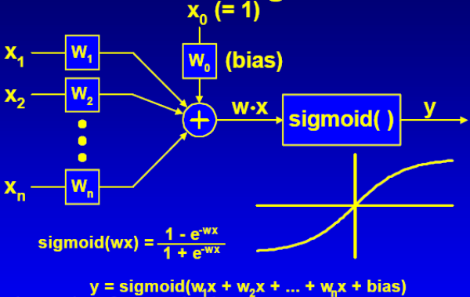
Figure 2, Neuron structure and activation function

Each neuron in ANN model is a kind of generic nonlinear functional element which has many input and each input associate with a weight. The neuron sum up all the weights*inputs and feed it to an activation function to give an activation value. Weights adjustment is very crucial in ANN building because it is the weights to determine the whole ANN activities. Here in this project, all the weights are initialized as a random value which is range from -1 to 1.
Output y = W * Sigmoid ( 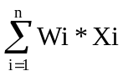 ), Xi inputs, i=1, 2… n
Threshold may apply to the neuron output. If it is less than specific value, output can be zero.

Step 3: Neural Network Back-propagation training processes

Here, a feed-forward network i denoted by inputs, j hidden neuron units, and k output units, L learning rate, E error, neuron output O, target output T, for example, Output ‘O’ from a neuron k be given Ok and target output is given Tk, Error is given Ek, etc. The algorithm is as follow:
1. Start from output layer:
- The error value for each neuron Ek = ( Tk – Ok ) * Ok * ( 1 – Ok )
To change the weight between a unit j in the hidden layer and an output unit k,
Wjk += L * Ek * Oj
2. Then adjust hidden layer’s weights:
Ej = Oj * ( 1 – Oj ) * 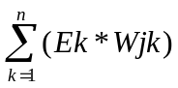
Wij += L * Ej * Oj

This entire process is repeated until the error value over all these trainings has been reduced to an acceptable level. After dozens times training tests, we found that the ANN model usually need to take about 500 to 10000 epochs to converge into a specific error threshold we set and complete the weights adjustment by back-propagation algorithm.

Step 4: Experiment data (input vector sets) generation for training
Output vector for training

Before we feed the effective input vector into neural network, we should have exact output information (vector) on hand, so the ANN can know the right direction to adjust the weights by back-propagation training method.

Each output pattern vector corresponds to each input vector. As the input data we already known the exact shape (standard shape, like standard triangle and square), so the type of pattern can be easily determined according to the relationship between the output and input. As we found that each classification type has an output neuron is a better case, so the output vector was built by related input vector’s desired output array.

Step 5: ANN model and software work flow in this project

Step 6: Two extra ANN techniques applied to improve ANN performance

- Adding Momentum to prevent local minima:
The back-propagation algorithm attempts to reduce the error of the neural network a little in each epoch. We can imagine the network having an error landscape. Each iterations, the algorithm determines the gradient of the error at current point in the landscape and attempts to move the error value toward a global minimum. However, most error landscapes are not nearly so smooth. Therefore, if we don’t be careful, it is easy to get stuck in local minima. The Momentum is used to avoid this situation. To do so, we can add a friction of previous time step’s weight update to current weight update. This help the algorithm to zip past any small fluctuation in the error landscape, thereby, giving better chance to find the global minimum.

Replace Wij+=L* Ej *Oi with Wij += L * Ej * Oi + m * ^ Wij.

- Adding jitter (noise) to prevent ANN over-fit to the training set, therefore, avoid losing the generalized ability.
As a neural network is basically a function approximator, so giving a training set, the ANN attempts to find the function that fit the input data to the output data. Sometimes, it can learn too well and lose the generalized ability which causes the over-fit problem. To prevent this happen, we can add some jitter which is a kind of ‘noise’ to the training data set. This can help the ANN to avoid fitting any specific data set too closely and therefore, in some situations can prevent the over-fitting. Another way is to minimize the hidden layer neuron number which we mentioned in the step 2. The implementation is easy to do which just add some small random value to input vector when we update the ANN to output in the training process.

Step 7: Test and verify the ANN model

After complete the training process, the big and crucial next step is the verification and tuning procedure which can not only verify the model effect, but also help to tune the ANN parameters. The main ANN parameters need to tweak and tune are as follow
a) Sigmoid response coefficient (1.0); b) Bias (1.0); c) learning rate (0.1); d) error threshold (0.7); e) Epoch threshold; f) Momentum rate (0.5); g) Jitter rate (0.2)

Each time we run the model program, training and input the testing data, then just tune one or two of these parameters to help separating the effect of each other. After dozens test, we conclude all the project used parameters value which are listed in the followed parentheses. Once these parameters are settle down, the other tests are easy to finish, just run this model program and all result show up on screen. For this purpose, we also built a separated test program to measure the program parameter’s setting and performance. Most of this part is discussed in the section 3.

3.3 Mouse Gesture Program Design and Implementation

The ANN model was built by Visual C++ on windows. The main program structure for this project was shown in figure 3, as follow:
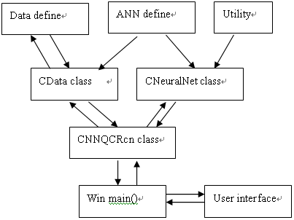
Figure 3, ANN model program structure

The whole procedures are explained as follow step by step in figure 4:
- Collect out-of-control data &generate input vector
- Scale data
- Back-propagation to adjust weights in training or update NN output in testing mode
- Examine the output data
- Obtain corresponding shift type base on the NN result
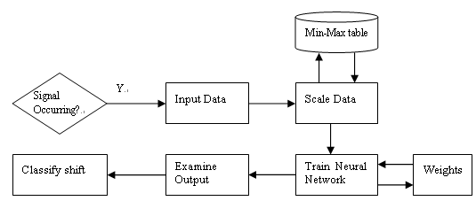
Figure 4, Project ANN model work flow

The ANN procedures see are explained as follow step by step in figure3:
Collect out-of-control data &generate input vector
Scale data
Back-propagation to adjust weights in training or update NN output in testing mode
Examine the output data
Obtain corresponding shift type base on the NN result

As each vector of rough data has practically different length, vectors must be somehow transformed to the assumed length to facilitate classification.

This project program has eight main modules list as above figure. As we applied C++ class model, it provides clearer structure and better reuse ability. The core class of ANN is the CNeuralNet classes which define the ANN structure of this project, all the core analysis and calculation functions. CNNQCRcn class works as a bridge between user interface and ANN core, and it also collect all the gesture input vector and smooth/scale the input data. The CData class collect and handle all the default basic pattern data, include the ‘left’, ‘right’, ‘up’, ‘down’, and ‘square’. ANN define procedure is the main place to go for tweak and tuning the parameter of whole program. Win main() handles all the mouse input and response the user key board activation.

In this software product, the mouse gesture input sequence, drawing direction and the start and end relative positions are essential for the success of ANN recognition. The different gesture input sequence or too much different gesture angle changed with original recorded input lead the ANN to show the low possibility or even wrong result. In most cases, it is good for accurate show the recognition result.

The great part of this ANN program is that the applied ANN can provide a great generalization capability by which customer can draw their gesture pattern or signature on any place of the input window if he/she follows the similar gesture pattern and sequence, and the program still can have a very high chance to give correct response.

The main program flow chart is list as follow see figure4:
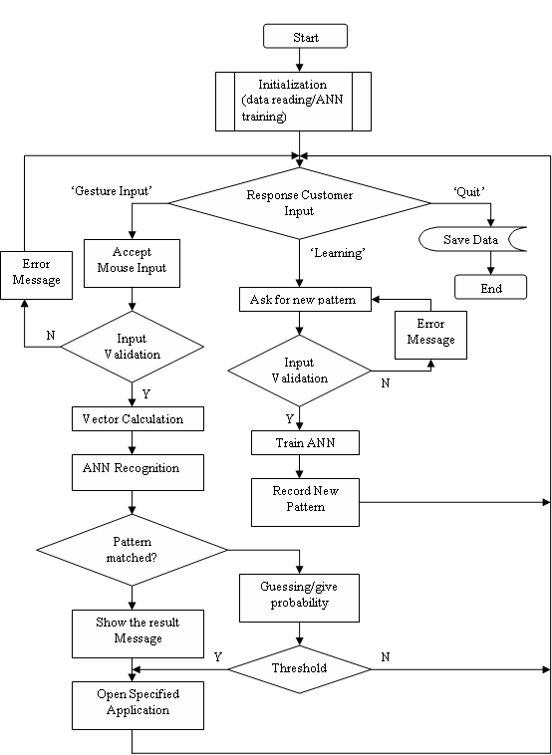

Figure 4: main program flow chart

Base on the program flow chart, we can show how the program run and how it handles the user input clearly. The main procedure separate into ‘Gesture Input’, ‘Learning’ and ‘Quit’ subroutines which response the user keyboard input. If it is ‘Gesture Input’ the program sample and collect the user mouse movement on the input window and then apply ANN to classify the pattern. If the pattern is not sure, then give the guessing/ possibility value. If it is in the ‘learning mode’ the program turn into a student, it can learn any input mouse gesture, record the user new gesture name and specified application name which the user want to open by this gesture. If user selects ‘Quit’, the program records all the data and re-trains the ANN and then exit the program.

4. Quality Control
Quality cannot be achieved by assessing an already completed product. The aim, therefore, is to prevent quality defects or deficiencies in the first place, and to make the products assessable by quality assurance measurements. Some quality assurance measures includes: structuring the development process with a software development standard and supporting the development process with methods, techniques, and tools. In addition to the product assessment, the process assessments are the essential to a quality management program. Examples include documentation of coding standards, prescription and use of standards, methods, and tools, procedures for data backup, test methodology, change management, defect documentation, and reconciliation. The greatest payback is with prevention. Increasing the emphasis on prevention reduces the number of defects that go to the customer undetected, improves product quality, and reduces the cost of production and maintenance.

Software testing is a popular risk management strategy. It is used to verify that functional requirements were met. The limitation of this approach, however, is that by the time testing occurs, it is too late to build quality into the product. However, not all defects are discovered during testing. The major purpose of verification and validation activities in the software testing is to ensure software design, code, and documentation meet all the requirements imposed on them.

Quality control is defined as the processes and the methods used to monitor work and observe whether requirements are met. It focuses on reviews and removal of defects before shipment of the product. Quality control should be the responsibility of the organizational unit producing the product. Quality control consists of well-defined checks on a product that are specified in the product quality assurance plan. For software products, quality control typically includes specification reviews, inspections of code and documents, and checks for user deliverables. Quality control can be provided by various sources. For small projects, the project personnel’s peer group can inspect the documents. Inspections are traditional functions of quality control, that is, independent examinations to assess compliance with some stated criteria. Responsibility for can perform the inspections. Quality control is designed to detect and correct defects, whereas quality assurance is oriented toward preventing them.

For our project, since we are following the standard and traditional development processes, namely “water fall” model, for every phase in the developing process, verification and validation were conducted for making sure we were producing the right product. In the Design phase, after the preliminary design, we would do a quick design review to ensure that the customer requirements were met. After detailed design, we would go back to the customer requirements and make sure whether or not some other requirements were proposed. In the implementation phase, since the project is small, we did peer-review on the code and document, and made corrections immediately; all the changes were documented through change control management plan. One of the most important phases is software testing. For our project, we made several types of test plans. As the testing was integrated into the software implementation, we adopted some popular testing techniques for the application.

- black-Box Testing (Functional)
- white-Box Testing (Structural)
- Manual Testing
- Static Testing

The following is a table indicating the test we conducted:
Techniques | Manual | Static | Functional | Structural
Acceptance testing | * |  | *
Black-Box Testing | * |  | *
White-Box Testing | * | * |  | *
Boundary Value | * |  | *

4.1 Team Contract (Quality)
Team Contract:
Positions:
Project manager: Gang Hu
Product engineer (software developer): Gang Hu & BeiChen Li
Quality engineer: BeiChen Li and Yi Huang
Support Engineer: Malik Qasaimeh

Responsibilities:
a) Project manager: Ensuring that the Project Team completes the project. The Project Manager develops the Project Plan with the team and manages the team’s performance of project tasks. It is also the responsibility of the Project Manager to secure acceptance and approval of deliverables from the Project Sponsor and Stakeholders. The Project Manager is responsible for communication, including status reporting, risk management, escalation of issues that cannot be resolved in the team, and, in general, making sure the project is delivered in budget, on schedule, and within scope.

b) Product engineer:

- Create product technical/functional design specifications based upon input gathered from R&D, Product Development, Marketing, and Sales resources.

- Develop and execute product development plans that effectively manage the delivery of products, packaging and marketing collateral from initial conception through end-of-life.

- Manage all product development lifecycle, including drawings, technical specifications, quality documentation, and product prototypes & samples.

- Manage contract manufacturer communications, deliverables, production performance, and all supplier sourced design correspondence.

- Partner with Product Development to value engineer product specifications.

- Establishes functional, technical and compliance quality standards, approves first article production prototypes prior to consumer release.

- Prepares project timelines and milestones and facilitates coordination of all product development tasks and activities with other Monster departments.

- Provides periodic status updates on all product development activities.

- Validates approved product profit goals at every stage of development.

- Provide technical support to other departments as required.
c) Quality engineer:
- Develop, apply and maintain quality requirements and standards for development and manufacture of products.

- Perform Quality tests and maintain records on systems.

- Serve as the primary Quality Assurance for problem identification, resolution, loss reporting and continuous improvement.

- Support concurrent engineering efforts by participating in design development projects representing Quality Assurance.

- Design and implement methods for process control, process improvement, testing and inspection.

- Promote and execute quality standards, inspection processes, test methodology, quality plans, documents and reports.

- Assist in process certification.

- Develop, execute and analyze quality-reporting measures.

- Report to management on quality issues, trends and losses.

- Review suppliers purchase orders and establish supplier quality requirements.

- Participate in internal and external quality audits.

- Interface with supplier quality representatives concerning problems which arise with quality assurance and assure that effective corrective action is implemented.

- Lead the effort in acquiring regulatory compliance for equipment.

d) Support Engineer:
- Deliver timely and high quality customer support focused on root cause.

- Log all information about customer questions/problems and follow through to resolution.

- Answer technical questions related to the use of the software, and troubleshoot performance and operating problems.
- Interface with development team to resolve software bugs or escalated support calls.

- Provide assistance in the installation of software and conduct remote system troubleshooting as needed.

- Provide desktop support to internal staff.

- Other tasks or projects as assigned.

Terms and condition:
1) Any member who wants to quit the project should inform others especially the project manager two weeks in advance.

2) Every member should finish his jobs and duties for this project on time. No exception.

3) Each week after the class is project group talk time. Each member should take part in on time, no excuse.

4) All members should keep in touch in the whole product development life cycle.

4.2 Quality Measurement and Quality test
We created a separated test program (combine with main program later) to measure our program performance under quality control.

This program recognizes user’s mouse gesture, if matches the known pattern, it can open a specific application, and otherwise, it can give a guessing result and possibility. As users can draw the mouse on any direction and any position on the input window, so the program needs to have a good generalized capability to give relative close answer. For example, the system trained all six basic patterns under specific standard shape and position data like a square or triangle, but the user can draw his square or triangle on any place of the screen and any rotation angle. This may cause a wild guessing even to a human’s eyes. However, as we applied ANN and ANN has a great ability to generalize, so this problem can be solved under good quality control ways.

In this project, we built this kind of test program to check and improve our ANN performance. It generalizes a standard shape first (triangle and square), then rotate it to a fixed angle, record the guessing possibility value, and then increase a specific steps on the angle to do the test again. It can rotate from -45 degree to 45 degree, under 30 steps. We record the result and draw many statistic charts as a reference, corresponding to each test group. This is a good reference for us to tweak and tune the ANN parameter to improve its performance and especially the generalized capability.

According to ISO 9000:2000, the definition of Quality improvement is "Part of quality management focused on increasing the ability to fulfill quality requirements." Also, according to Juran, the activities in companies that assure quality can be grouped in three processes: quality planning, quality control and quality improvement. In this project, we focus on the quality improvements on several critical parameters for the functions of the application. Typically, quality improvement activities are conducted in projects. Statistics offers a range of methods for the collection, presentation and analysis of data. Underlying these methods is the framework of mathematics and mathematical modeling. Typically in statistical methods, a major role is played by the notion of uncertainty and the mathematical solution to deal with it, namely: probability, and—closely linked—the concept of random variation. This uncertainty arises when one realizes that an actual data set is just a specimen of a set of possible outcomes that one might have obtained in the given situation just as well. As a consequence, inferences that are made from data should take into consideration not only the data themselves, but also the alternative outcomes that would have been possible. Statistical methods do this and by doing so enable an assessment of the reliability of a certain inference—by regarding observed data as realizations of random variables.

In this project we want to find out the optimum values for four critical parameters, which seriously affect the quality of the recognition by the mouse movements. In the improvement process, we collected a large number of data for each parameter, and based on the observations, graphs, and statistical data analysis, we would conclude the preferred values for parameters. According to the design of the program, we have four essential parameters, namely, Learning Rate, Error Threshold, Momentum Rate, and Jitter Rate. For Learning Rate, we collected 12 group data, from 0.1 to 1.2 in each group, and the data differs when the angle changes from -45º to +45º each time. After that, we calculated the maximum value, minimum value, difference between maximum value and minimum value, mean, and variance for each group data. Furthermore, we computed the values of maximum difference, minimum difference, maximum mean, minimum mean, maximum variance and minimum variance from the group data. For the rest three parameters, we followed the same procedures for the calculations on the data. Finally, we made some statistical graphs using Minitab to indicate the results.
The algorithm for seeking the optimum value is as follows:
- Change one parameter for one step each time while keeping the rest parameters unchanged, as the parameters are independent each other.
- Collect the data.
- Increase the step by the pre-defined unit.
- Go back to step 2.
- Until the step equates the pre-defined upper limit.
- Make data analysis on the collected data.
- Pick up the optimum value for the parameter.
- Move to the next parameter.
- Do the same procedures as the first one keeping the rest unchanged.
- Until all the parameters are settled.
- Final result.

As we can see from the above Excel Spreadsheet, the probability of recognition differs both when the angle changes and the learning rate changes. From the shown data, we know when the Learning Rate is set to be 0.6, the probability of generalization recognition is better than other groups. Also, when the value is 0.6, the variance and the difference are minimal. Although the upper limits of the probability form some other groups are greater, but the lower limit on the probability is much lower than the one with Learning Rate 0.6. Evaluating the optimum value needs not only the data analysis but also the experiences and the real needs. Below is the Histogram for the group of data for which the Learning Rate is 0.6. We can clearly see that the most of probabilities are located between 82% and 85%. The scatter is smaller than others.

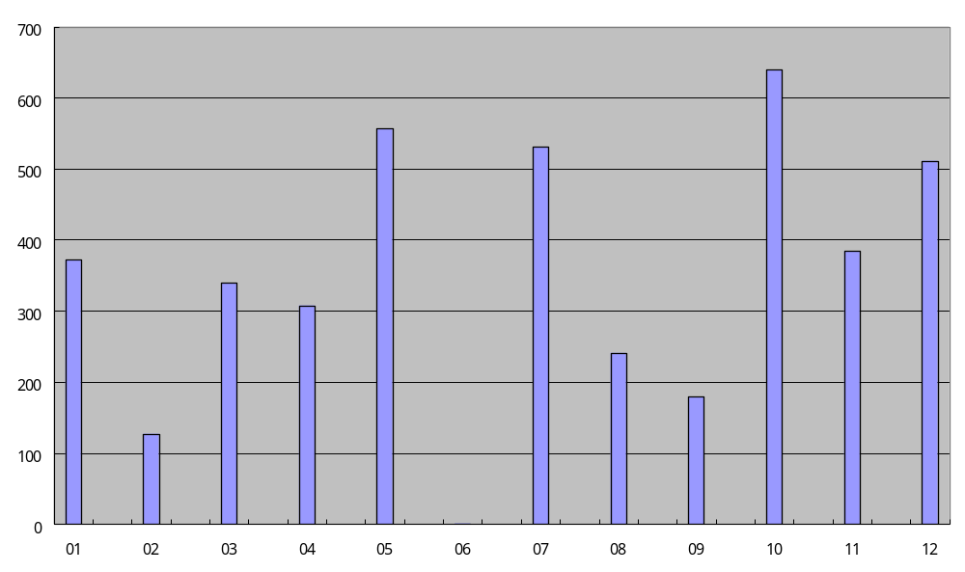

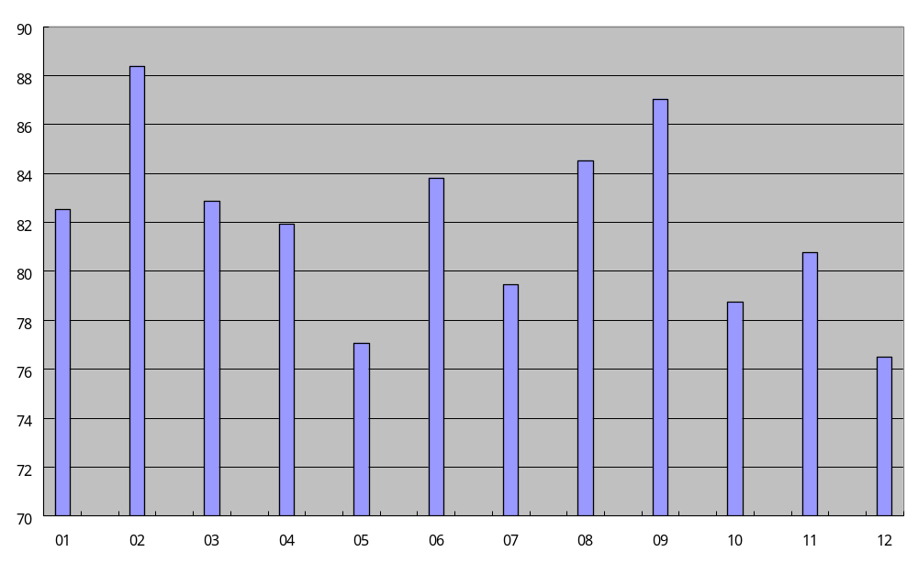
Comparison of means for Learning Rate

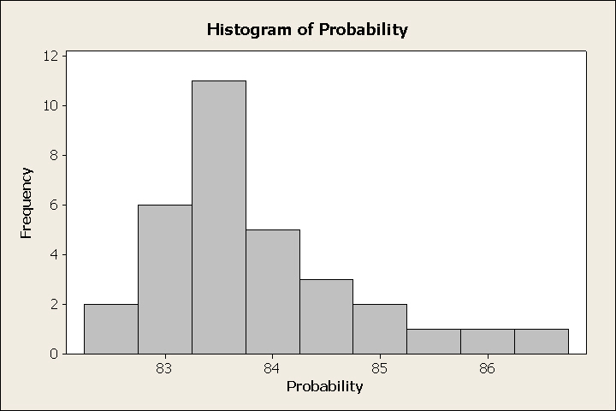
Histogram of probability when the Learning Rate is 0.6

For determining the Jitter Rate, we followed the same procedures as seeking optimal Learning Rate before but took 24 group data. But this time, we already set the optimal Learning Rate equating 0.6. From the data analysis, we would look at the means and the variances of the data since the scatter of the data is similar to each other. Now we found two values satisfying our needs, the Jitter Rate 0.05 and Jitter Rate 0.14. Both of the probabilities are good enough for recognition. Two pictures below show that the Jitter Rate 0.05 and the Jitter Rate 0.14 have the means of 86.9799 and 85.2345, the variances of 170.172 and 189.467, respectively. As a result, we could set the Jitter Rate either with 0.05 or with 0.14 as we like.
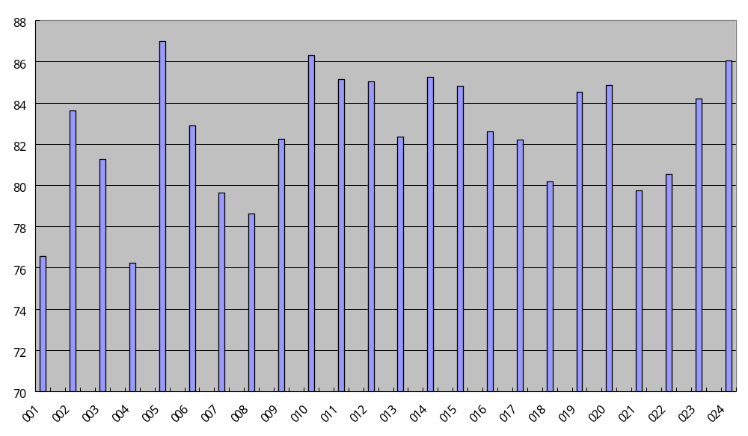Comparison of Means for Jitter Rate
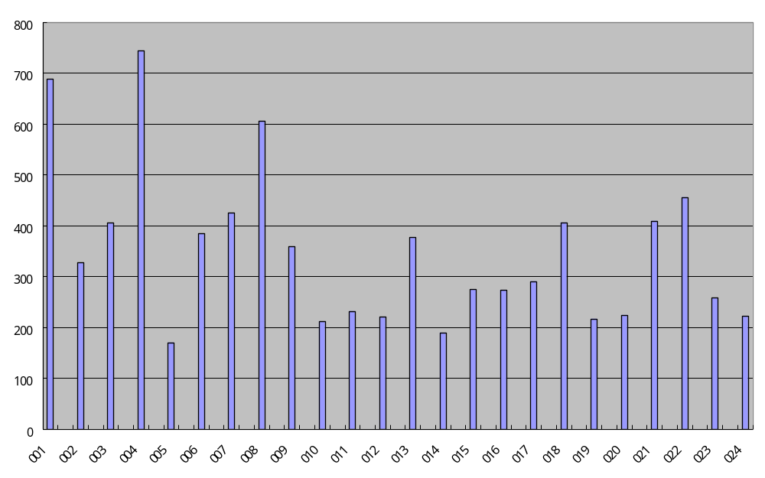
Comparison of variances for Jitter Rate
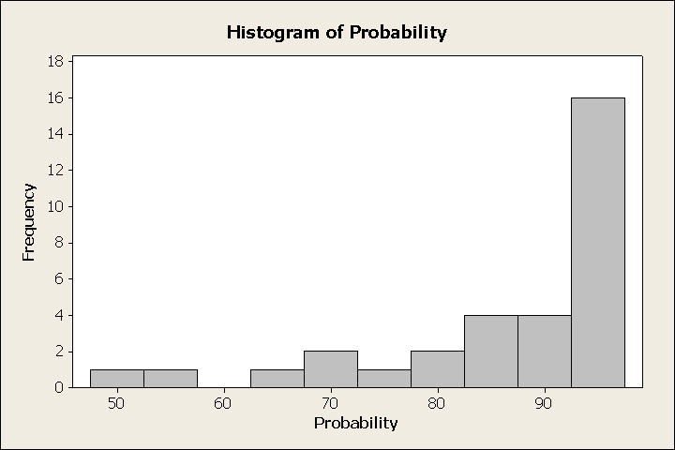
Histogram of probability when Jitter Rate is 0.05

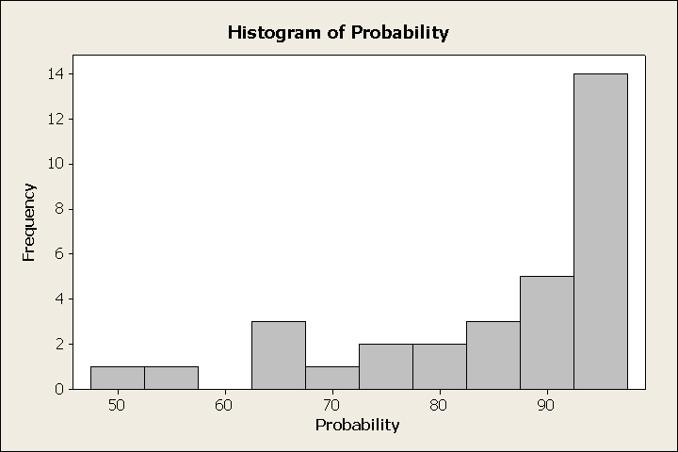
Histogram of probability when Jitter Rate is 0.14

Momentum Rate:
Up to now, we set two optimal parameters for the application. For finding out the optimal value for Momentum Rate, we still divided the pre-defined range into twelve steps. By looking at data in the spreadsheet, we noticed that when the rate is 0.1, the mean of probability is the highest followed with the rate 0.9. After careful selection, we decided to take the Momentum Rate equating 0.9 since the scatter of data with rate 0.9 is smaller than the data with rate 0.1, and the variance is smallest among the groups. The graphs below show the results visually.
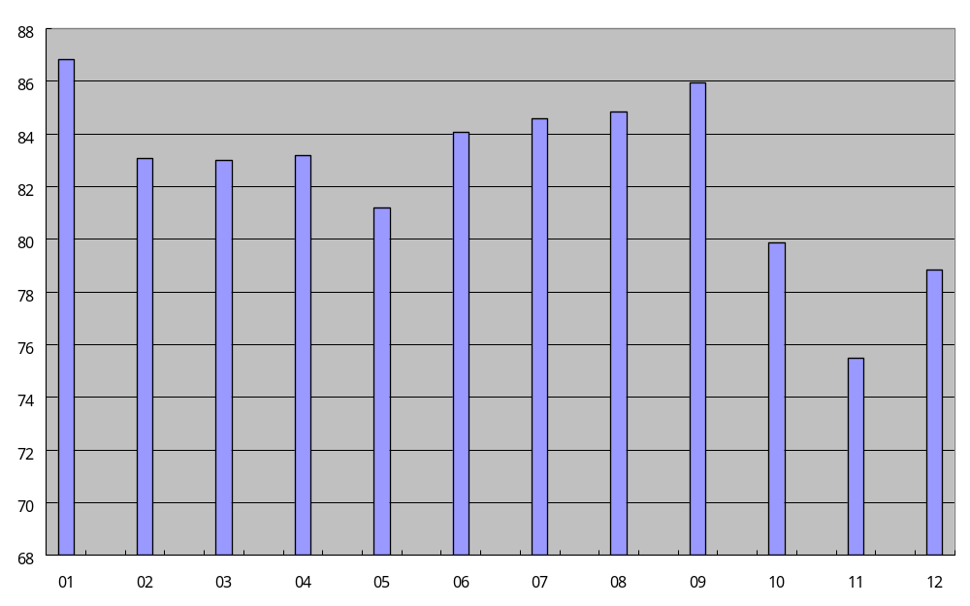
Comparison of means for Momentum Rate
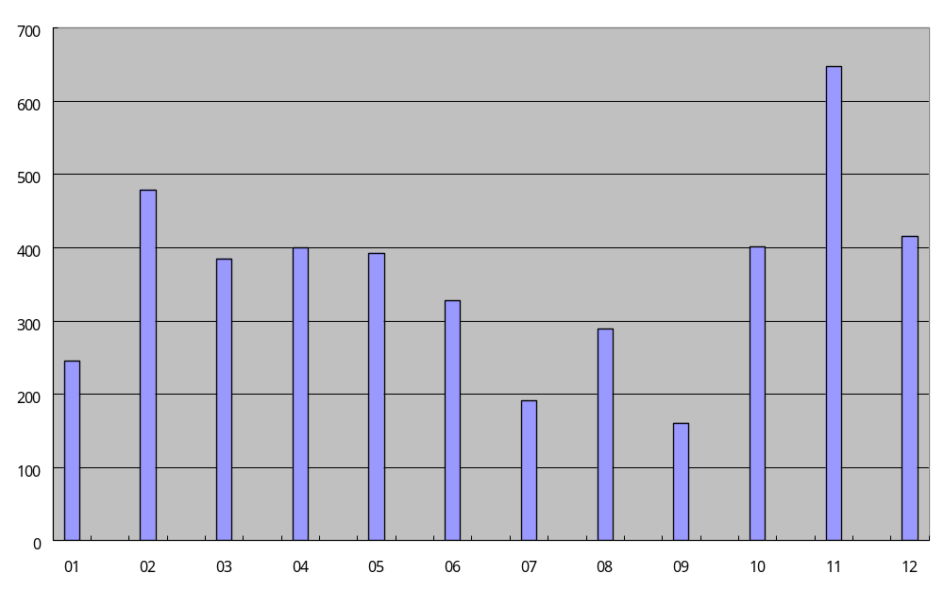
Comparison of variances for Momentum Rate
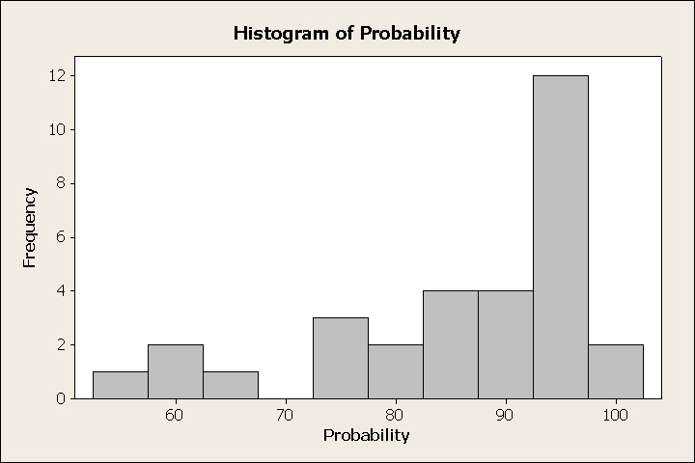
Histogram of probability when the Momentum Rate is 0.9

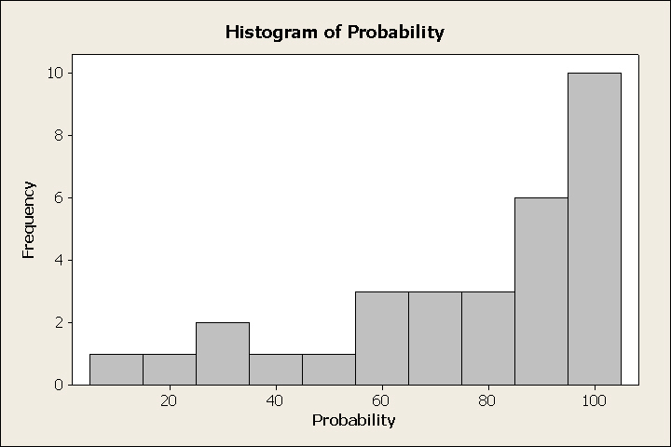
Histogram of probability when the Momentum Rate is 0.1

Error Threshold
Finally, we reached the Error Threshold parameter. We made the range for the error threshold from 0.01 to 0.1, and divided it into ten steps. Since higher than probability of 99% is not necessary and the speed of the convergence depends on the computation speed of machines. And in here, we just illustrated the examples, and if readers are interested in doing that further, there would not be a problem. From the data shown, the data with Error Threshold 0.02 is the optimum one, which has mean 87.775 and variance 152.333.
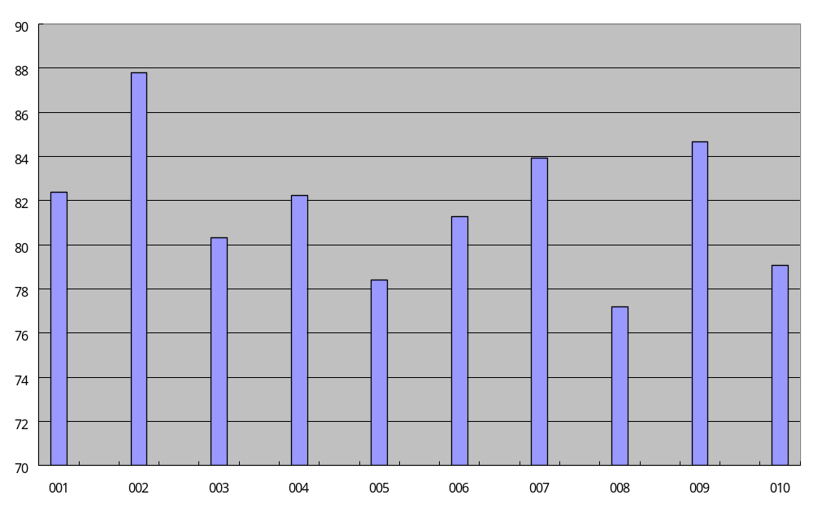
Comparison of means for Error Threshold
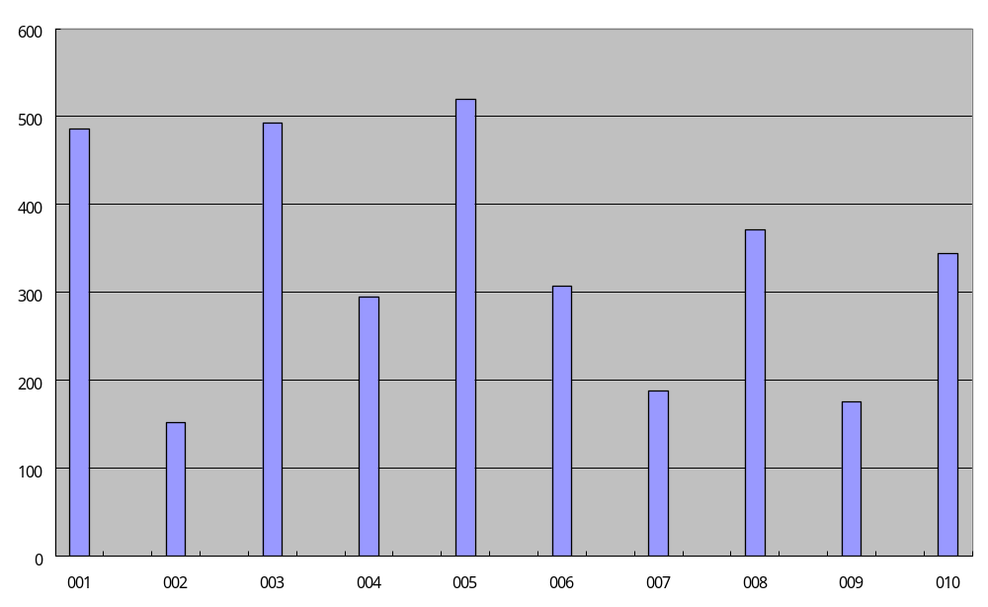
Comparison of variances for Error Threshold
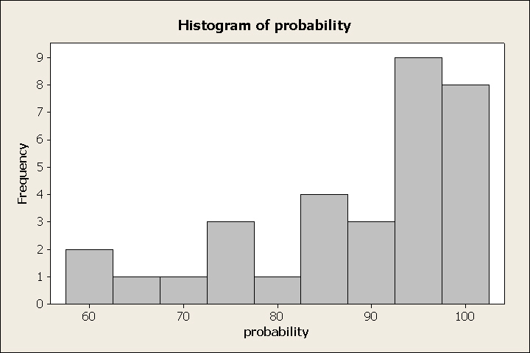
Histogram of probability when Error Threshold is 0.02

In the above study we show the optimum values chosen depend on maximum value, minimum value, difference between maximum value and minimum value, mean, and variance for each group data. Furthermore, we computed the values of maximum difference, minimum difference, maximum mean, minimum mean, maximum variance and minimum variance from the group data. For the rest three parameters,

Now we provide more detailed study that analyses the performance of guessing with different values for Learning Rate, Error Threshold, Momentum Rate, and Jitter Rate. For Learning Rate, in ordered to organize more detailed study of choosing the optimum values, we traced the program first with different values for jitter rate we randomly picked some value on the rate of [0.05, 0.14].

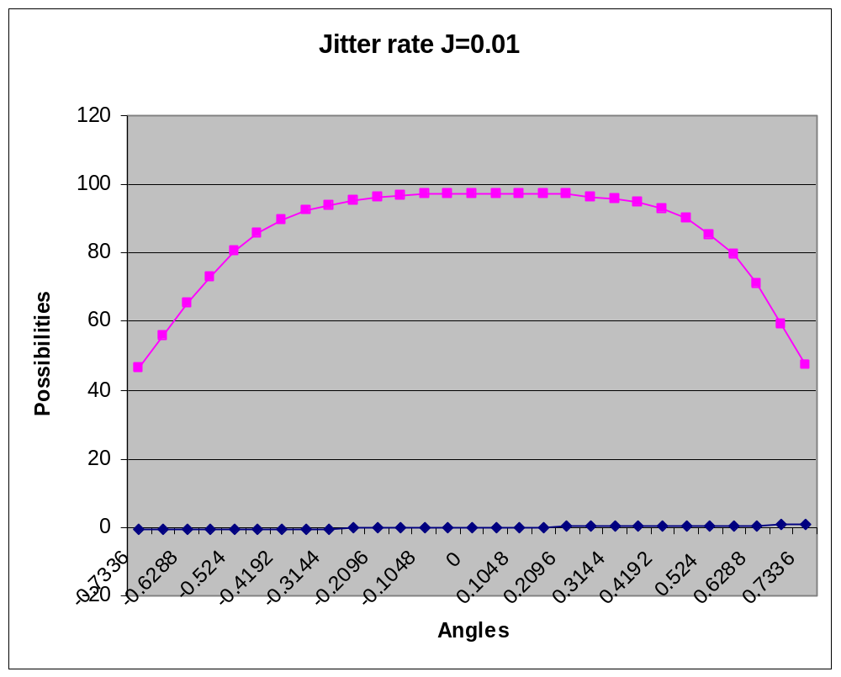

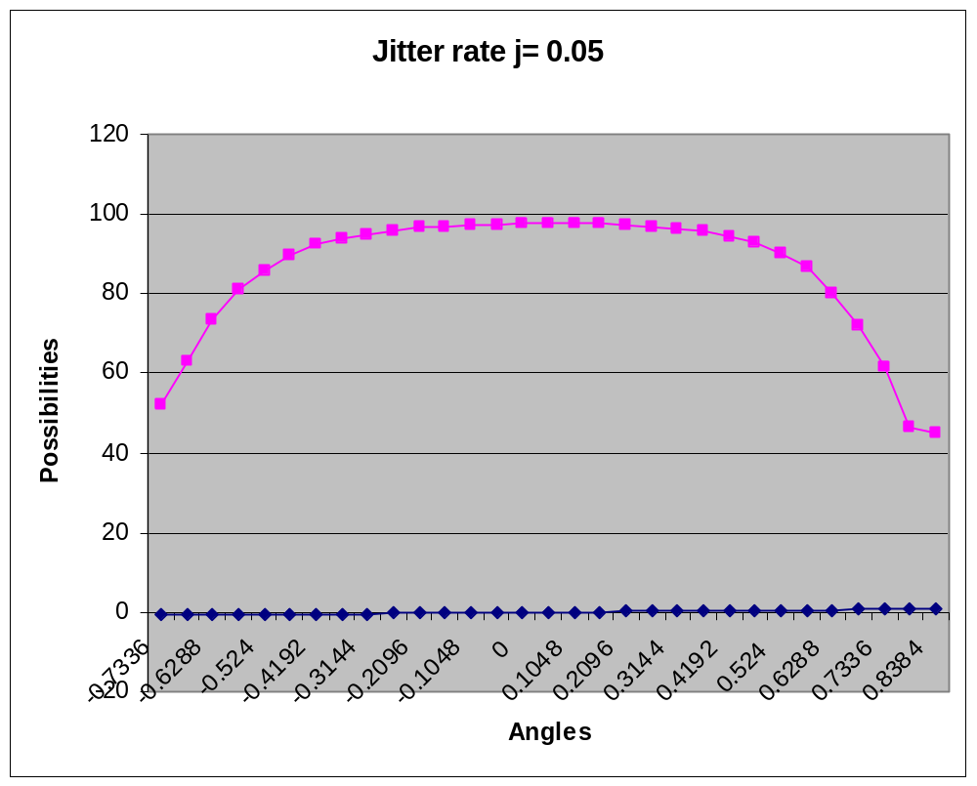

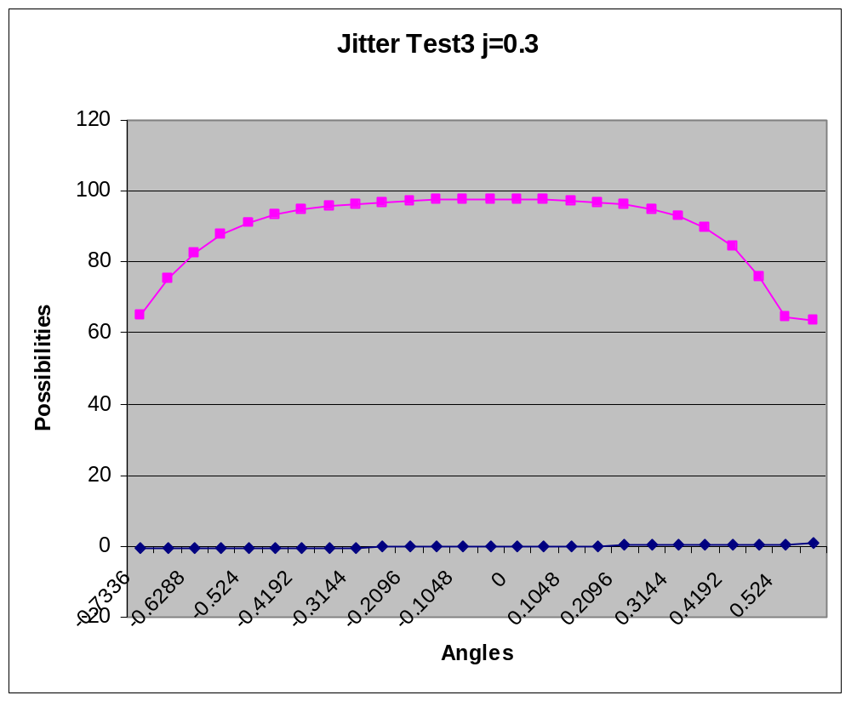

Clearly the plot shows that by compare variation of the plots, j=0.3 it could be the best value in the range of [0.05, 0.14].

More over we traced the program in a different value of the momentum rate aimed to pickup more detailed idea of choosing the optimum value.
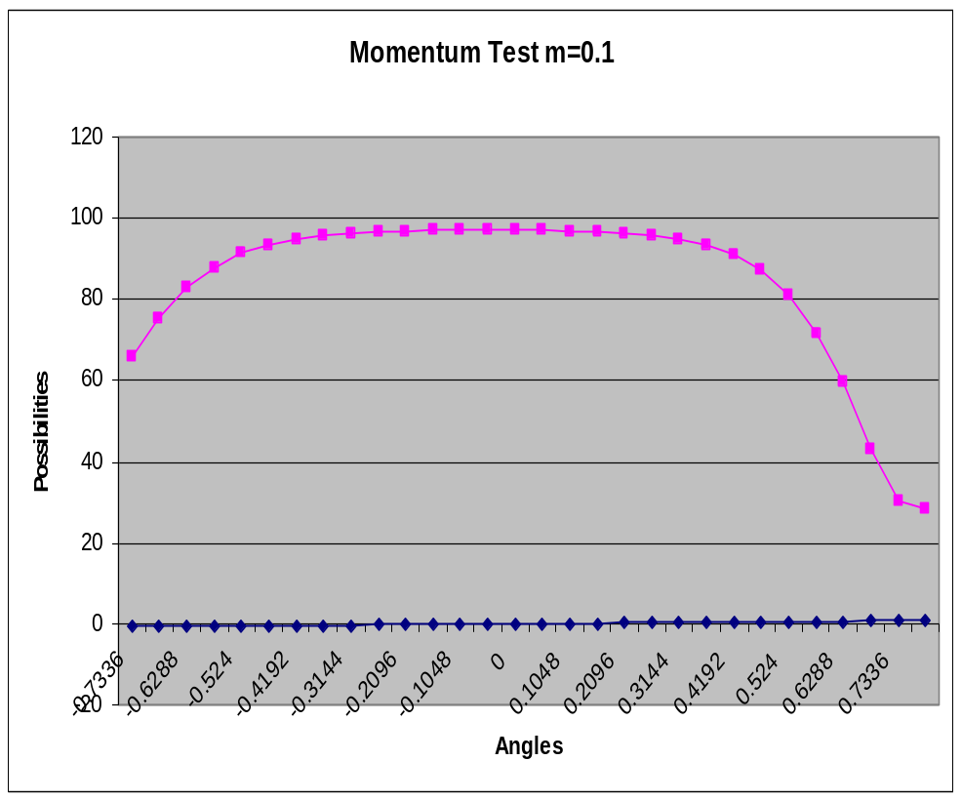

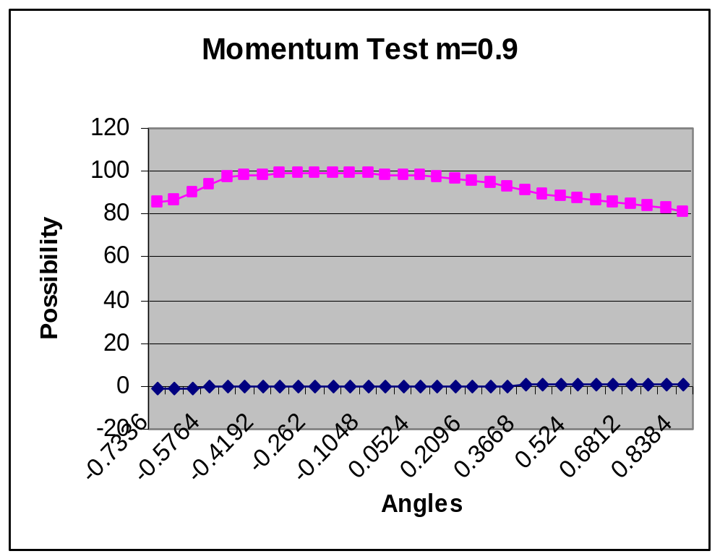

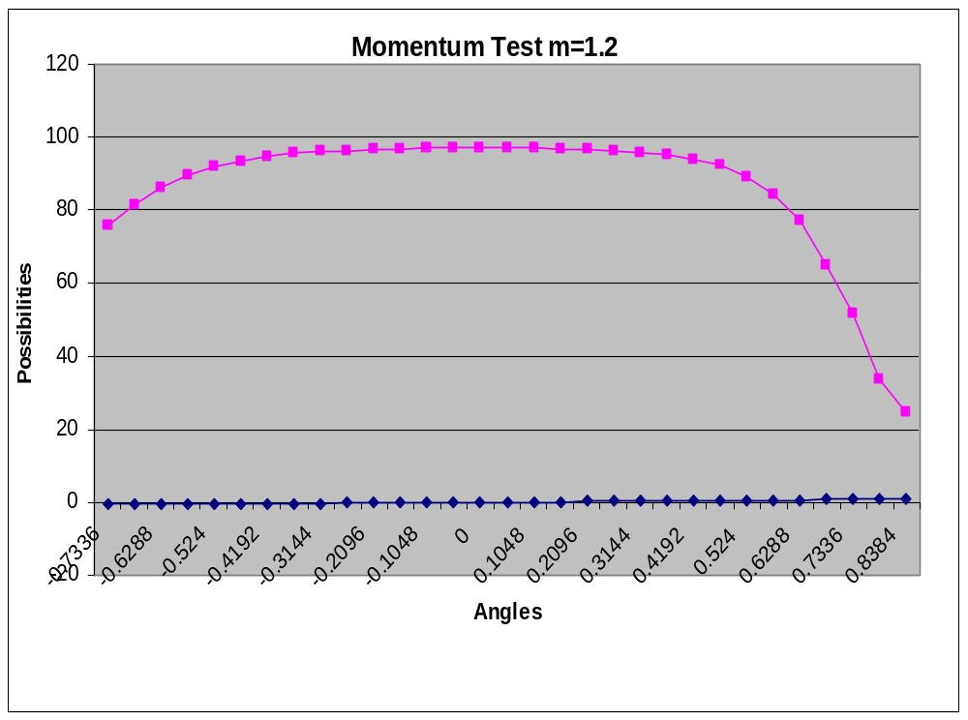

The graph above shows that m=0.9 cloud be the optimum value for momentum rate.

More experiments are added to analyse the program for different values for learning abilities
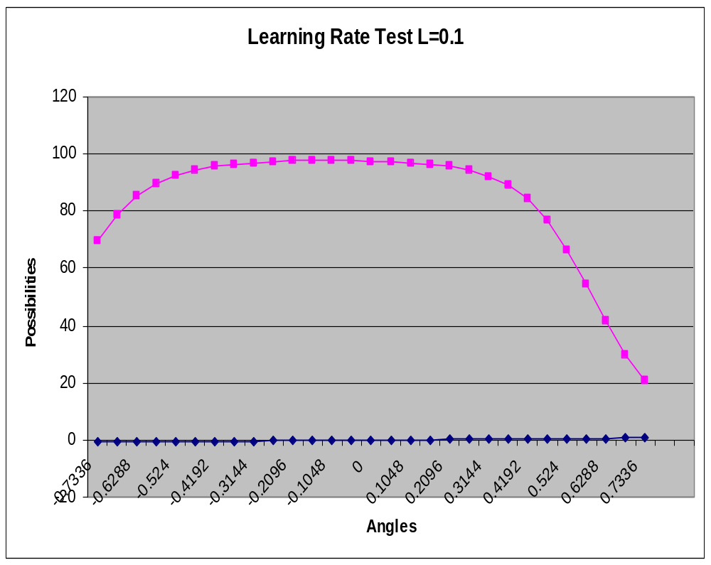

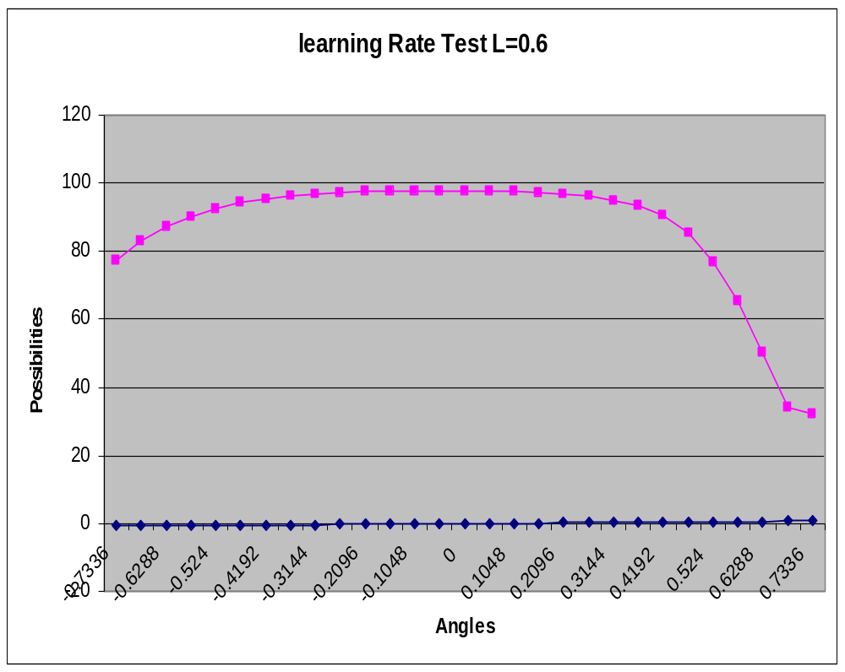

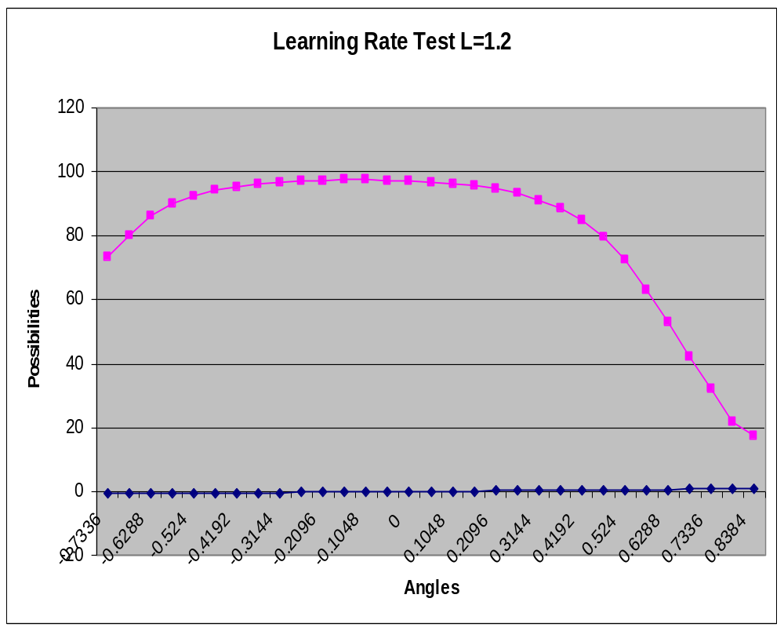

The experiment shows that the optimum value for learning ability can be found with L=0.6

For experiment are added to obtain the optimum value of Neuron per hidden which provides a number of hidden neural network.

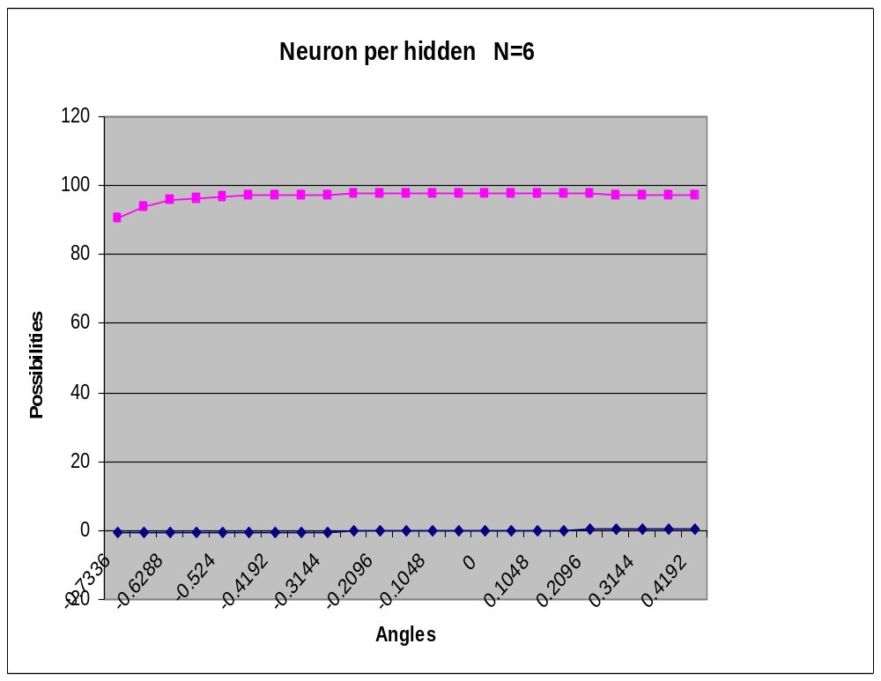

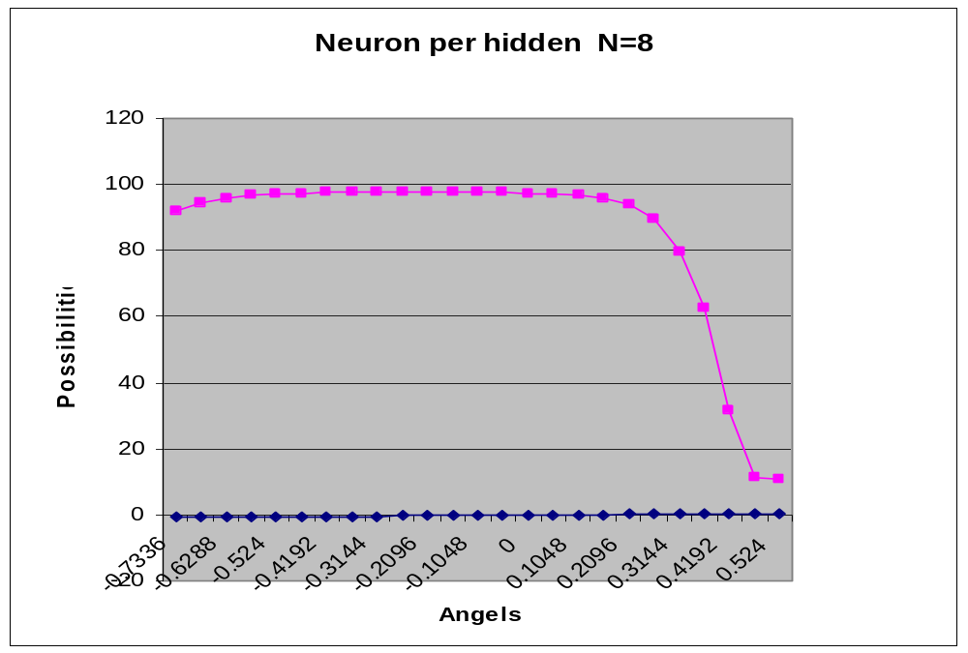

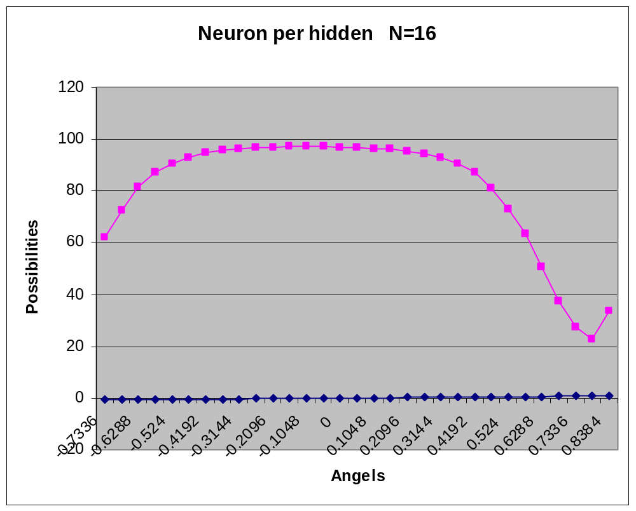

The figure shows clearly that N=6 could be the optimum value for neuron per hidden parameter

4.3 Quality Control Tools

4.3.1 Communications

Brainstorming
Brainstorming is a group creativity technique that is designed to generate a large number of ideas for the solution of a problem. Brainstorming is a lateral thinking process. We come up with ideas and thoughts that seem at first to be a bit shocking or crazy. We can then change and improve them into ideas that are useful, and often stunningly original. During brainstorming sessions there should therefore be no criticism of ideas: We are trying to open up possibilities and break down wrong assumptions about the limits of the problem. Judgments and analysis at this stage can stunt idea generation.

Fishbone diagram
The fishbone diagram originally developed by Professor Kaoru Ishikawa is often referred to as an Ishikawa Diagram. The technique can help to structure the process of identifying possible causes of a problem. The diagram encourages the development of an in depth and objective representation ensuring all participants keep on track. It discourages partial or premature solutions, and shows the relative importance and inter-relationships between different parts of a problem. The method is ideally organized over a number of meetings, enabling the team to become deeply immersed in the problem. Fresh suggestions regarding possible causes can arise during the break and members are more likely to forget who originated every idea, thus making subsequent discussions less inhibited.

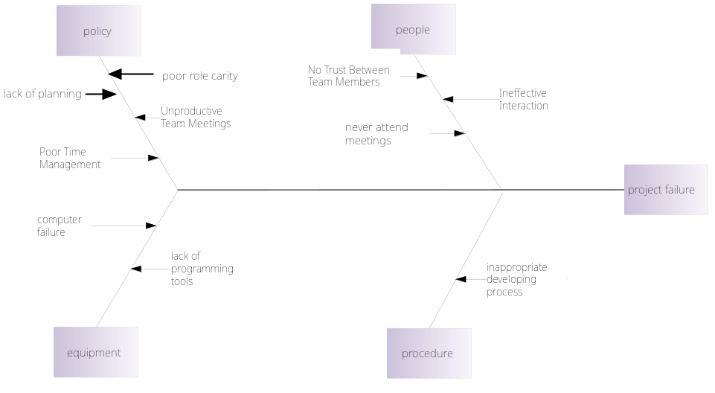

Figure 6: Fishbone diagram

4.3.2 Schedule

Gantt chart:

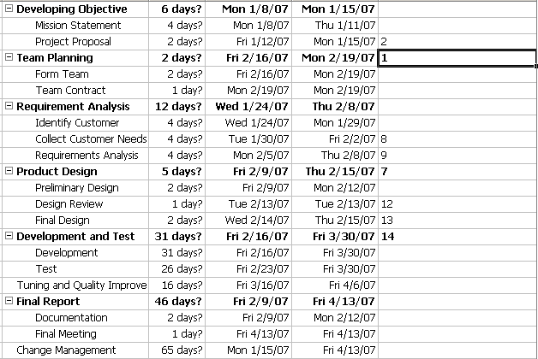

5. Quality Improvement
According to ISO 9000:2000, the definition of Quality improvement is "Part of quality management focused on increasing the ability to fulfill quality requirements." Also, according to Juran, the activities in companies that assure quality can be grouped in three processes: quality planning, quality control and quality improvement. In this project, we focus on the quality improvements on several critical parameters for the functions of the application. Typically, quality improvement activities are conducted in projects. Statistics offers a range of methods for the collection, presentation and analysis of data. Underlying these methods is the framework of mathematics and mathematical modeling. Typically in statistical methods, a major role is played by the notion of uncertainty and the mathematical solution to deal with it, namely: probability, and—closely linked—the concept of random variation. This uncertainty arises when one realizes that an actual data set is just a specimen of a set of possible outcomes that one might have obtained in the given situation just as well. As a consequence, inferences that are made from data should take into consideration not only the data themselves, but also the alternative outcomes that would have been possible. Statistical methods do this and by doing so enable an assessment of the reliability of a certain inference—by regarding observed data as realizations of random variables.

5.1 Product quality improvement
For the high usability of gesture-based interface, three basic features must be preserved: accuracy, efficiency (of recognition), and adaptability to the possibilities and needs of the individual user. Accuracy is understood as the percentage of properly recognized gestures in relation to the intention of the users performing them. Efficiency should be enough for the use on an average computer. Adaptability means easy registration of the own classes of gestures of the given user.
The quality of the solution should be tested during usability assessment.

Poor quality results in product waste and dissatisfied customers. We aimed in our project to improve the quality of product by improving the features and performance of design and process. Based on some kind of balance between accuracy and generalization, we achieved some improvements as follow:

1) No action sequence is demanded for the basic shape recognition, like triangle and square. In the old version, we needed to follow the specific drawing sequence strictly (start point and end point), now the updated version doesn’t consider the drawing sequence, no CCW and CW demand.

2) The right mouse clicking action is switched to left one, which is more convenient for most program users.

3) Better generalization

4) The updated version leaves customer gesture drawing trace with sample vector point showing on screen.

5) Automatic generalization for test data is presented to achieve better ANN performance

6) The updated version allows the automatic test and measurement to evaluate the ANN performance.

7) The rotation and position changes are recorded into file for the future analysis use.

8) The ANN basic shapes are recorded and trained weights are saved into a file, so no training is required for next start.

9) ANN can be learned by the user data/new gestures, which provides the program the self-learning ability.

10) Such basic and easy mouse gesture patterns as up, down, lift and right are used for some most frequently used applications.

11) Some more complicated patterns could be reserved for advanced users or application use.

12) Users can change the specific applications which will be opened.

13) The program is named as Smart Mouse which is more attractive and easy to understand by users.

14) User interface window is created to be larger than before.

5.2 Prove the Need
We combine this step into our whole design procedure. That is we separated the product development into a few small parts. After we finished each small prototype part, we asked our customers to test and verify if it satisfied their original need. Then based on the feedback, we could try to improve our design.

5.3 Identify Potential Team Improvement Projects
We establish our team in flexible ways.
1) Communication: The first barrier is the language.
2) Schedule: We only can choose the weekday night time for our group meeting.
3) Background: We try to take advantage of each member’s specific work and study background.
4) Commuting issue

5.4 Organize Project Team
Refer to section 2.1.

5.5 Diagnose the Possible Causes of Team Failure
There are some possible reasons as follow:
- No Trust between Team Members
When team members don’t trust each other or are suspicious of each others motives, the end result is a team that is not cohesive in its approach.
- Ineffective Interaction and Unproductive Team Meetings
All the complexities of team dynamics come to the fore at the meeting. The meeting is one of the most critical aspects of the team process with strategies and innovative solutions to problems emerging during this time.
- Poor Role Clarity
Role clarity is a must in a team situation. When roles are not clearly defined, this can lead to conflict and confusion on tasks.
- Poor Time Management
A team should plan its goals and activities whilst keeping time constraints and deadlines in mind, otherwise their efficiency level in managing and implementing a task can suffer.

5.6 Provide Remedies and Prove that the Remedies are Effective
We have some solutions for the cause of a team failure as follows:
1. No Trust between Team Members
We separated the project duties clearly and make sure each member understands his position and what he should do base on his own interest and background.
2. Ineffective Interaction and Unproductive Team Meetings
Before each meeting, we have clear goals, and then we have brainstorming, and ask each member to well prepare and take part in positively.
3. Poor Role Clarity
From early stage of project, we define the role and responsibilities for each team member.
4. Poor Time Management
We make a clear meeting schedule and apply some software tools to help us to deal with the time management under control. And every time before the group meeting, the project manager sends the email notification to every member.

6. Conclusion

In this project, we applied quality base engineering knowledge to develop a software product which is an ANN moue gesture recognition application with an integrated measurement/test tool that can help us to tweak and tune the ANN performance. All the program and the ANN model is programmed in C++ which could provide more flexibility, higher execution speed and more expandable and under thorough control. Also we used two extra ANN techniques to improve the performance by adding Momentum (friction) and Jitter (noise) in the training and result updating procedure. The test and measurement are very important for this project program (especially the ANN model). We built a separate test program to find the relative best parameter settings for the ANN in which consider the balance of accuracy and generalization ability.

All in all, we learnt a lot useful knowledge through this project development and gain hands-on experience on how to apply the system quality engineering to guide a whole software development procedure. And also this project especially in the ANN related to quality control field.

7. Reference:
[1] Hung T. Nguye, “A first course in Fuzzy and Neural control”, 2003
[2] Gruau, F. (1995). “Automatic definition of modular neural networks”. Adaptive Behavior, 2, pp.151-183.
[3] Elman, J. L. (1993). “Learning and development in neural networks: The importance of starting small”. Cognition, 48, 71--99.

[4] B. Schiele and A. Waibel. “Gaze tracking based on face-color. In Proc. Int. Workshop on Auto. Face and Gesture Recog ”., pages 344--349, Zurich, 1999

[5] Bandinelli, S., Fuggetta, A., Lavazza, L., Loi, M. and Picco, G. P. (1995). "Modeling and Improving an Industrial Software Process," IEEE Transactions on Software Engineering, 21(5):440-454

[6] Frank M. Gryna Quality Planning and Analysis (Fifth Edition), McGraw-Hill Irwin

Appendix:
In the appendix the experiment data for each parameter is presented

